Classification Assignment
Problem Statement or Requirement: A requirement from the Hospital, Management asked us to create a predictive model which will predict the Chronic Kidney Disease (CKD) based on the several parameters. The Client has provided the dataset of the same.
1.) Identify your problem statement : predict the Chronic Kidney Disease
2.) Tell basic info about the dataset (Total number of rows, columns)
There are 399 rows and 25 columns.
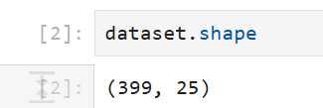
3.) Mention the pre-processing method if you’re doing any (like converting string to number – nominal data)

4.) Develop a good model with good evaluation metric. You can use any machine learning algorithm; you can create many models. Finally, you have to come up with final model.
5.) All the research values of each algorithm should be documented. (You can make tabulation or screenshot of the results.)
6.) Mention your final model, justify why u have chosen the same. Note: Mentioned points are necessary, kindly mail your document as well as .ipynb (code file) with respective name. ϖ ϖ Sub file name also should be properly named for Example (SVM_Ramisha_Assi-5.ipynb) Communication is important (How you are representing the document.)
Kindly uploaded in the Github and Share it with us

Evaluation Metrics:
SVM
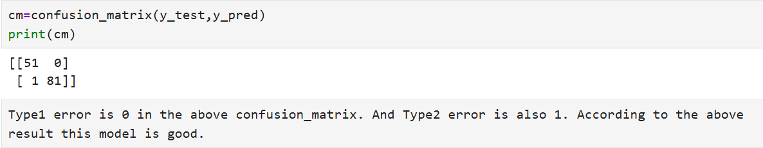
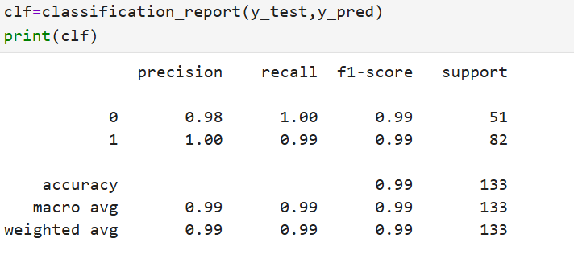
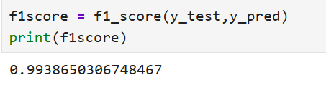
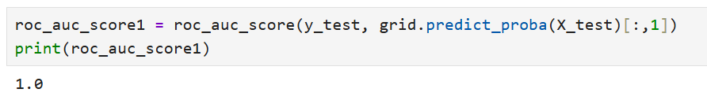

DecisionTreeClassifier:
